

Python Practical’s

# TASK 1

Smit Joshi | 06-08-2023

# Practical 1

## Write a program to print numbers from 1 to 50

for i in range(1,51):

    print(i,end=" ")

### Output:



# Practical 2

## Write a program to print all the numbers b/w 11 to 100 which are multiple of 7

for i in range(7,100,7):

    print(i,end=" ")

### Output:

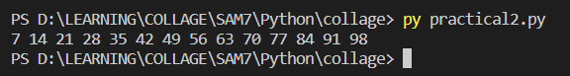

# Practical 3

## Write any Program to print numbers from 75 to 21 in reverse order

i=75

while i>=21:

    print(i,end=" ")

    i-=1

### Output:



# Practical 4

## # Write a program to get 3 numbers from USER AND find the largest number from it and print the result

num1=int(input("Enter number 1 "))

num2=int(input("Enter number 2 "))

num3=int(input("Enter number 3 "))

if num1>num2 and num1>num3:

    print(f"{num1} is largest")

elif num2>num3:

    print(f"{num2} is largest")

else:

    print(f"{num3} is largest")

### Output:

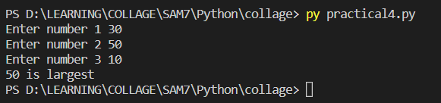

# Practical 5

## # Write a program to take percentage of student as an input and display the grade of student

## if per >=85 Grade A

## per >=75 and <85 Grade B

## per >=65 and <75 Grade C

## per >=55 and <65 Grade D

## per >=40 and <55 grade E

## per <40 Grade F

percentage=int(input("Enter Percentage: "))

grade=''

if percentage >=85: grade='A'

elif percentage >=75 and percentage<85:grade='B'

elif percentage>=65 and percentage <75:grade='C'

elif percentage>=55 and percentage<65:grade='D'

elif percentage>=40 and percentage<55:grade='E'

elif percentage<40:grade='F'

print(f"Your Grade is {grade}")

### Output:

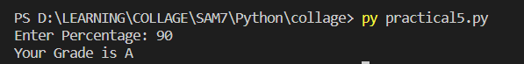

# Practical 6

## # Write a program to take input from user and find wheather the number is even or odd

number=int(input("Enter Number : "))

if number%2==0:

    print(f"{number} is Even")

else:

    print(f"{number} is odd")

### Output:

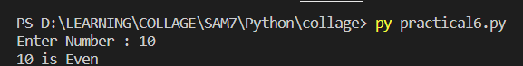

# Practical 7

## #Write a program to take 7 numbers from user and calculate the sum of THOSE 7 NUMBERS & DISPLAY RESULTS

sum=0

for i in range(1,8):

    sum+=int(input(f"Enter Number {i} "))

print(f"the summation is {sum}")

### Output:

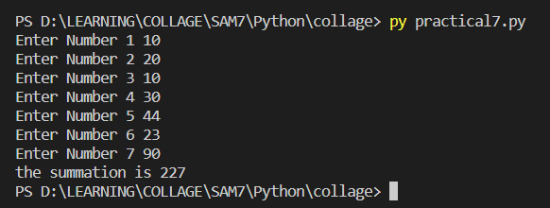

# Practical 8

## # Write a program to calculate sum of all the numbers b/w 71 to 80

sum=0

for i in range(71,81):

    sum+=i

print(f"The sum is {sum}")

### Output:

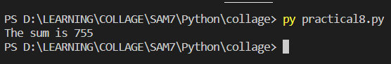

# Practical 9

## # Write a program to find the product of all the numbers b/w 21 to 30

product=1

for i in range(21,31):

    product*=i

print(f"The product is {product}")

### Output:

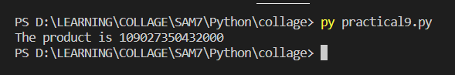

# Practical 10

## #Write a program to find the given number is prime or not

number=int(input("Enter Number : "))

flag=False

for i in range(2,number//2):

    if number%i==0:

        flag=True

        break

if not(flag): print(f"{number} is Prime Number")

else: print(f"{number} is not a Prime Number")

### Output:

